Multi threading
_____________________________________________________________________________________
Q. What is thread?
_____________________________________________________________________________________
Thread is a sub part of process, or it is light weight process.

Q. What is process?
_____________________________________________________________________________________
Program running in memory called as process or if any application or software running in memory called as process.

Q. What is multi threading?
_____________________________________________________________________________________
Multi threading means when we execute multiple threads simultaneously or waiting of each other called as multi threading.
Note: Threading is a concept of Operating System and Java is implementer language of thread concept.

How to implement thread using JAVA
_____________________________________________________________________________________
If we want to implement thread using java we have two ways.
1. Using Thread class
2. Using Runnable interface

How to implement the thread using Thread class
_____________________________________________________________________________________
If we want to implement the thread using Thread class, we have some important steps.

1. Add java.lang package in application
_____________________________________________________________________________________
import java.lang.*;
Note: java.lang is a default package of java not need to import it.

2. Create class and inherit the Thread class in it.
_____________________________________________________________________________________
Syntax:
class classname extends Thread
{
}
Example: class A extends Thread
{
}
Note: if we think about class A it is not a simple it is Thread class because class A contain all properties of Thread class.

3. Override its run() method and write thread logic _____________________________________________________________________________________
Note: run() is not method of Thread class just it is a method from Runnable interface and Thread is a implementer class of Runnable interface.
Internal working of Thread class
_____________________________________________________________________________________
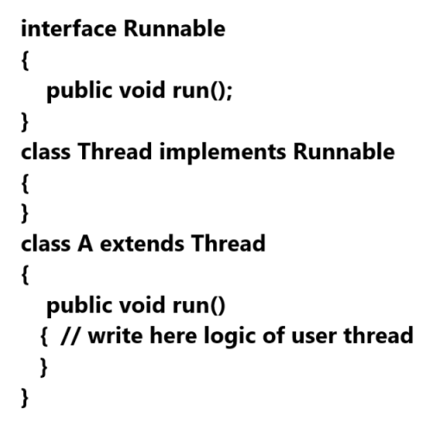
Sample code
class A extends Thread
{
public void run()
{
try
{
for(int i=1; i<=5; i++)
{
System.out.printf("First Thread is %d\n",i);

}
}
catch(Exception ex)
{ System.out.println("Error is "+ex);
}
}
}

4. Create object of Thread child class
_____________________________________________________________________________________
As per our example
A a1 = new A();
5. Use methods of Thread for manage the thread
_____________________________________________________________________________________
If we want to work with thread we have some inbuilt method provided by Thread class to us

void start(): this method can start the new thread or start thread means when we call start() method internally run() method get executed.
Note: we not need to call run() method it is call by JVM internally when we call start() method of Thread and when we call run() method manually it is not work as thread method.

static void sleep(int milliseconds): this method can hold thread execution for a specified time period and when we call this method we need to handle the InterruptedException and it category of checked exceptions.

void join(): this method can hold the thread execution whenever running thread is not completed
or working thread not finish its execution

boolean isAlive(): this method is used for check the status of thread means if this method return true consider thread is in execution and if this method return false thread not in execution.

void stop(): this method can terminate the thread execution or destroy thread.

void wait(),notify(),notifyAll(),yield() etc we will see this method later in this chapter.

Example of Multi threading using start() ,run() and sleep() method
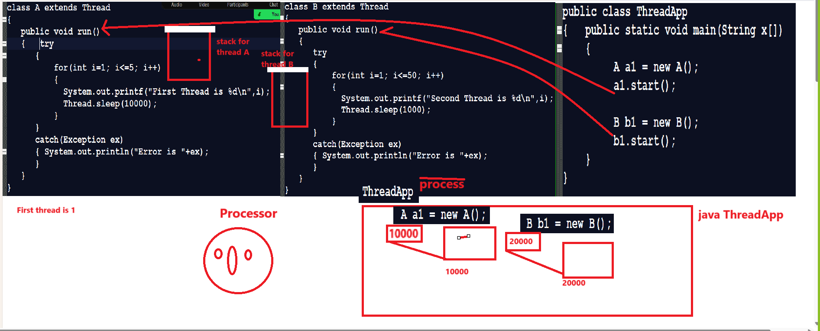

Example with source code
class A extends Thread
{
public void run()
{ try
{
for(int i=1; i<=5; i++)
{
System.out.printf("First Thread is %d\n",i);
Thread.sleep(10000);
}
}
catch(Exception ex)
{ System.out.println("Error is "+ex);
}
}
}
class B extends Thread
{
public void run()
{
try
{
for(int i=1; i<=50; i++)
{
System.out.printf("Second Thread is %d\n",i);
Thread.sleep(1000);
}
}
catch(Exception ex)
{ System.out.println("Error is "+ex);
}
}
}
public class ThreadApp
{ public static void main(String x[])
{
A a1 = new A();
a1.start();

B b1 = new B();
b1.start();
}
}

Now we want to discuss about the join() method
_____________________________________________________________________________________
join() method is used for hold the thread execution when ever running thread is not complete its execution if we think about above code we have two thread name as A and B so when A is on hold thread B execute in waiting of A and A execute in waiting of B
But we want to execute Thread A only event he has waiting period means hold execution of B then we can use join() method with Thread A so until terminate A, B not start by JVM
shown in following code

Example with source code
class A extends Thread
{
public void run()
{ try
{
for(int i=1; i<=5; i++)
{
System.out.printf("First Thread is %d\n",i);
Thread.sleep(10000);
}
}
catch(Exception ex)
{ System.out.println("Error is "+ex);
}
}
}
class B extends Thread
{
public void run()
{
try
{
for(int i=1; i<=50; i++)
{
System.out.printf("Second Thread is %d\n",i);
Thread.sleep(1000);
}
}
catch(Exception ex)
{ System.out.println("Error is "+ex);
}
}
}
public class ThreadApp
{ public static void main(String x[])throws InterruptedException
{
A a1 = new A();
a1.start();
a1.join();
B b1 = new B();
b1.start();
}
}
void stop(): terminate the execution of thread if we want to terminate first thread after third iteration

Now we want to discuss about the boolean isAlive():
_____________________________________________________________________________________
This method can check thread is live or not if thread is live return true otherwise return false.

class A extends Thread
{
public void run()
{ try
{
for(int i=1; i<=5; i++)
{
System.out.printf("First Thread is %d\t%b\n",i,isAlive());
if(i==3)
{ stop();
}
Thread.sleep(10000);
}
}
catch(Exception ex)
{ System.out.println("Error is "+ex);
}
}
}
class B extends Thread
{
public void run()
{
try
{
for(int i=1; i<=50; i++)
{
System.out.printf("Second Thread is %d\n",i);

Thread.sleep(1000);
}
}
catch(Exception ex)
{ System.out.println("Error is "+ex);
}
}
}
public class ThreadApp
{ public static void main(String x[])throws InterruptedException
{ A a1 = new A();
a1.start();
a1.join();
System.out.println("Now status of a1 is "+a1.isAlive());
B b1 = new B();
b1.start();
}
}

Synchronization and Asynchronization of thread
_____________________________________________________________________________________
Q. What is synchronization and Asynchronization?
_____________________________________________________________________________________
Synchronization: means if two or more than two threads use particular resource/object sequentially one by one called as synchronization.
Asynchronization: means if two or more than two threads use the particular resource/object simultaneously called as asynchronization

Example of asynchronization
class Table
{
void showTable(int no)
{
try{
for(int i=1; i<=10; i++)
{
System.out.printf("%d X %d = %d\n",i,no,i*no);
Thread.sleep(1000);
}
}
catch(Exception ex)
{ System.out.println("Error is "+ex);
}
}
}
class Two extends Thread
{ Table table;
void setTable(Table t)
{ table=t;
}
public void run(){
table.showTable(2);
}
}
class Three extends Thread
{ Table table;
void setTable(Table t)
{ table=t;
}
public void run(){
table.showTable(3);
}
}
public class TableSyncApp
{
public static void main(String x[])
{
Table t1 = new Table();

Two tw = new Two();
tw.setTable(t1);
tw.start();

Three th = new Three();
th.setTable(t1);
th.start();
}
}

Output
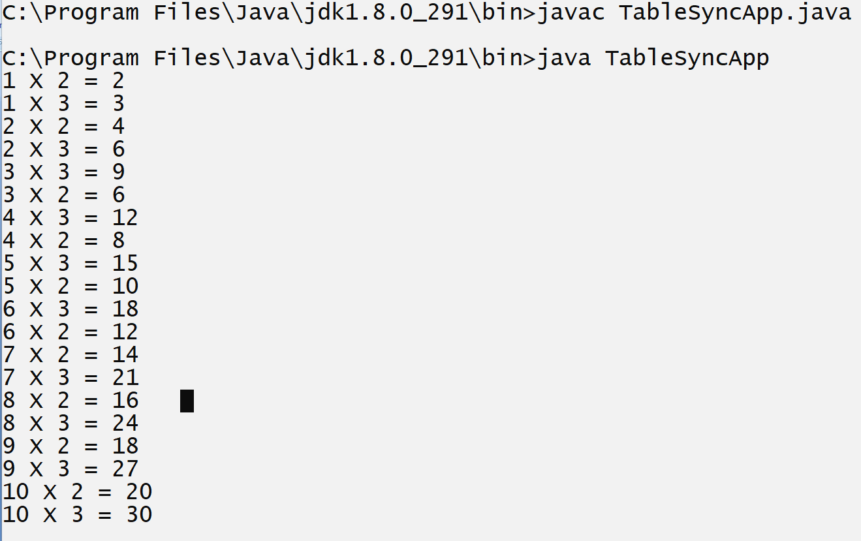

Example of synchronization
If we want to mark your resource as synchronized, we have to use synchronized keyword with function or method.
Example with source code
class Table
{
synchronized void showTable(int no)
{
try{
for(int i=1; i<=10; i++)
{
System.out.printf("%d X %d = %d\n",i,no,i*no);
Thread.sleep(1000);
}
}
catch(Exception ex)
{ System.out.println("Error is "+ex);
}
}
}
class Two extends Thread
{ Table table;
void setTable(Table t)
{ table=t;
}
public void run(){
table.showTable(2);
}
}
class Three extends Thread
{ Table table;
void setTable(Table t)
{ table=t;
}
public void run(){
table.showTable(3);
}
}
public class TableSyncApp
{ public static void main(String x[])
{ Table t1 = new Table();
Two tw = new Two();
tw.setTable(t1);
tw.start();
Three th = new Three();
th.setTable(t1);
th.start();
}
}
Output
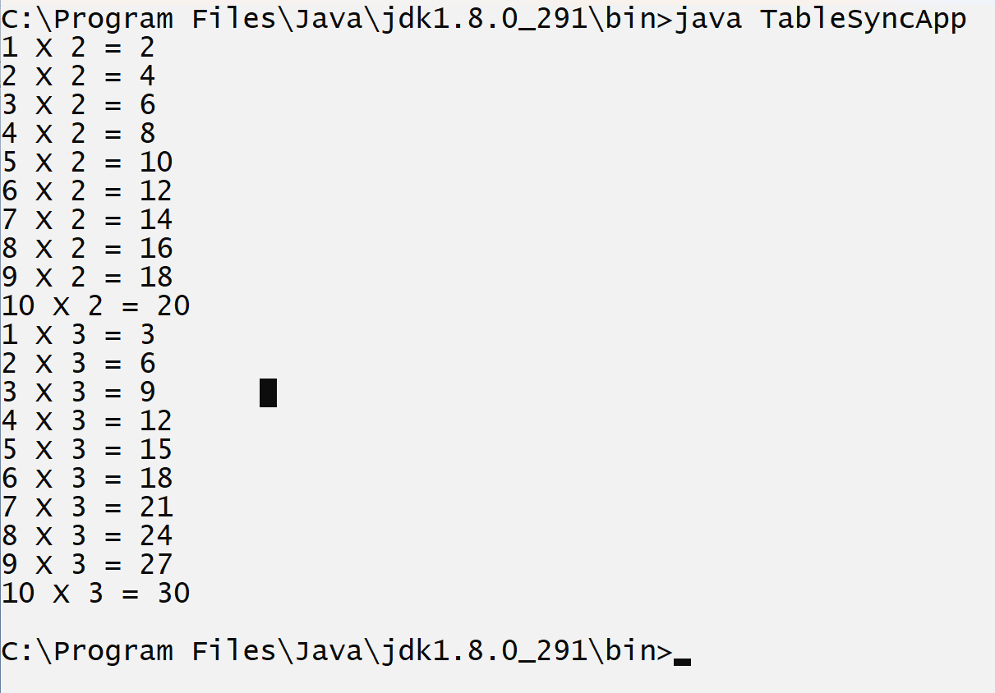

wait(),notify() and notifyAll() methods
_____________________________________________________________________________________
wait() method is used for hold thread execution for specified time period and wait() is originally method of Object class
There are two types of wait
_____________________________________________________________________________________
1. Conditional wait: conditional wait means thread stop its execution for specified time period and re- execute automatically after some specified time period called as conditional wait.
Syntax: void wait(int milliseconds);
2. Unconditional wait: unconditional wait means thread hold its own and not re-execute self again programmer need to send request to thread for re-execution purpose called as unconditional wait.
Syntax: void wait();

Example of conditional wait
class Table
{
synchronized void showTable(int no)
{
try{
for(int i=1; i<=10; i++)
{
System.out.printf("%d X %d = %d\n",i,no,i*no);
if(i==5)
{ wait(60000);
}
Thread.sleep(1000);
}
}
catch(Exception ex)
{ System.out.println("Error is "+ex);
}
}
}
class Two extends Thread
{ Table table;
void setTable(Table t)
{ table=t;
}
public void run(){
table.showTable(2);
}
}
class Three extends Thread
{ Table table;
void setTable(Table t)
{ table=t;
}
public void run(){
table.showTable(3);
}
}
public class TableSyncApp
{
public static void main(String x[])
{
Table t1 = new Table();

Two tw = new Two();
tw.setTable(t1);
tw.start();

Three th = new Three();
th.setTable(t1);
th.start();
}
}

Example of unconditional wait
If we want to recall thread from unconditional wait, then we have two methods
1. notify() : notify() method recall only one thread at time from unconditional wait and call the threads in first in first out format.
means first waiting thread call first and last waiting thread call last means using queue algorithm

2. notifyAll() : notifyAll() method can recall all waited thread at time in last in first out format
shown in following code
Example with source code
import java.util.*;
class Table
{
synchronized void showTable(int no)
{
try{
for(int i=1; i<=10; i++)
{
System.out.printf("%d X %d = %d\n",i,no,i*no);
if(i==5)
{ wait();
}
Thread.sleep(1000);
}
}
catch(Exception ex)
{ System.out.println("Error is "+ex);
}
}
synchronized void rejoin()
{
try{
notifyAll();
}
catch(Exception ex)
{ System.out.println("Error is "+ex);
}
}
}
class Two extends Thread
{ Table table;
void setTable(Table t)
{ table=t;
}
public void run(){
table.showTable(2);
}
}
class Three extends Thread
{ Table table;
void setTable(Table t)
{ table=t;
}
public void run(){
table.showTable(3);
}
}
public class TableSyncApp
{
public static void main(String x[])
{
Table t1 = new Table();

Two tw = new Two();
tw.setTable(t1);
tw.start();

Three th = new Three();
th.setTable(t1);
th.start();

do{
Scanner xyz = new Scanner(System.in);
String msg=xyz.nextLine();
if(msg.equals("restart"))
{ t1.rejoin();
}
}while(true);
}
}

Q. What is difference between sleep() and wait() method?

Sleep | Wait
Sleep method can hold thread execution for specified time period, and it is method of Thread class and work only with conditional wait | Wait() method is member of Object class and can work with conditional as well as unconditional wait
sleep() method can work in synchronized as well as asynchronized block | Wait() method can only works in synchronized block

Q. what is difference between notify() and notifyAll() methods ?
notify() method call one thread at time from unconditional wait using queue format and notifyAll() method can call all threads at time from unconditional wait using stack format.

Thread Priority
_____________________________________________________________________________________
Thread priority means decide starting sequence or priority of thread called as thread priority
Basically, there are three types of thread priority in Java
1. MIN Priority
2. MAX Priority
3. NORM Priority
If we think about thread class we have three fix constant values means thread class contain three static and final variable with some default value.

MAX priority: static final int MAX_PRIORITY=10
MIN PRIORITY: static final int MIN_PRIORITY=1
NORM Priority: static final int NORM_PRIORITY=5
Note: every thread has a default priority called as normal priority
If we want to set the priority on thread we have method name as
void setPriority(int priority): we can set priority to thread either min, max or norm or value between 1 to 10.
int getPriority(): this method can return priority of thread

Example with source code
import java.util.*;
class Table
{
synchronized void showTable(int no)
{
try{
for(int i=1; i<=10; i++)
{
System.out.printf("%d X %d = %d\n",i,no,i*no);
if(i==5)
{ wait();
}
Thread.sleep(1000);
}
}
catch(Exception ex)
{ System.out.println("Error is "+ex);
}
}
synchronized void rejoin()
{
try{
notifyAll();
}
catch(Exception ex)
{ System.out.println("Error is "+ex);
}
}
}
class Two extends Thread
{ Table table;
void setTable(Table t)
{ table=t;
}
public void run(){
table.showTable(2);
}
}
class Three extends Thread
{ Table table;
void setTable(Table t)
{ table=t;
}
public void run(){
table.showTable(3);
}
}
public class TableSyncApp
{
public static void main(String x[])
{
Table t1 = new Table();

Two tw = new Two();
Three th = new Three();
tw.setTable(t1);

th.setPriority(Thread.MAX_PRIORITY);
tw.setPriority(Thread.MIN_PRIORITY);

th.setTable(t1);

tw.start();
th.start();

do{
Scanner xyz = new Scanner(System.in);
String msg=xyz.nextLine();
if(msg.equals("restart"))
{ t1.rejoin();
}
}while(true);
}
}

Q. Can we create java program without thread?
_____________________________________________________________________________________
No, we cannot create java program without thread because every program has one default thread name as main thread and main thread has default priority i.e. normal priority
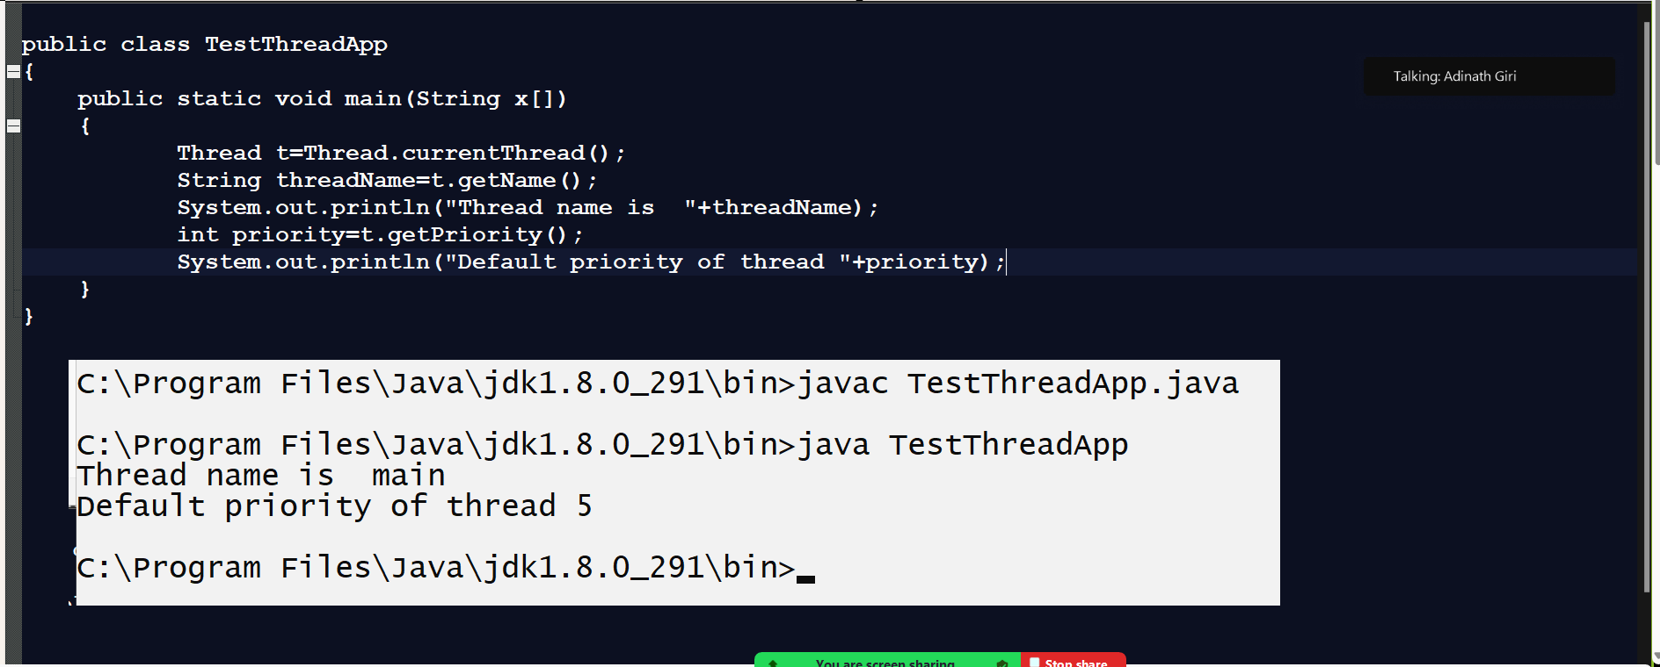

Q. What is daemon thread in Java?
_____________________________________________________________________________________
Daemon thread is a service provider thread means we can say daemon thread can execute in background for provide service to another thread and terminate at last.
Example of daemon thread: Garbage collector
Note: user can mark own thread as daemon thread and for that we have method name as
void setDaemon(boolean): when we pass true in this method then your thread work as daemon thread
boolean isDaemon(): this method can check your thread is a daemon or not if this method return true then your thread is daemon if return false then not daemon

Example with source code
class T extends Thread
{
public void run()
{
try{
for(int i=1; i<=5; i++)
{
System.out.printf("I = %d\n",i);
Thread.sleep(1000);
}
}
catch(Exception ex)
{ System.out.println("Error is "+ex);
}
}
}
public class TestThreadApp
{
public static void main(String x[])
{
T t=new T();
t.setDaemon(true);
t.start();
}
}

